Product page: Gravity: Analog Turbidity Sensor for Arduino - DFRobot
Tutorial page: Gravity: Analog Turbidity Sensor for Arduino | DFRobot Wiki
Code examples (for Arduino only): Example Code for Arduino-Analog Output of Gravity: Turbidity Sensor (SEN0189) - DFWiki

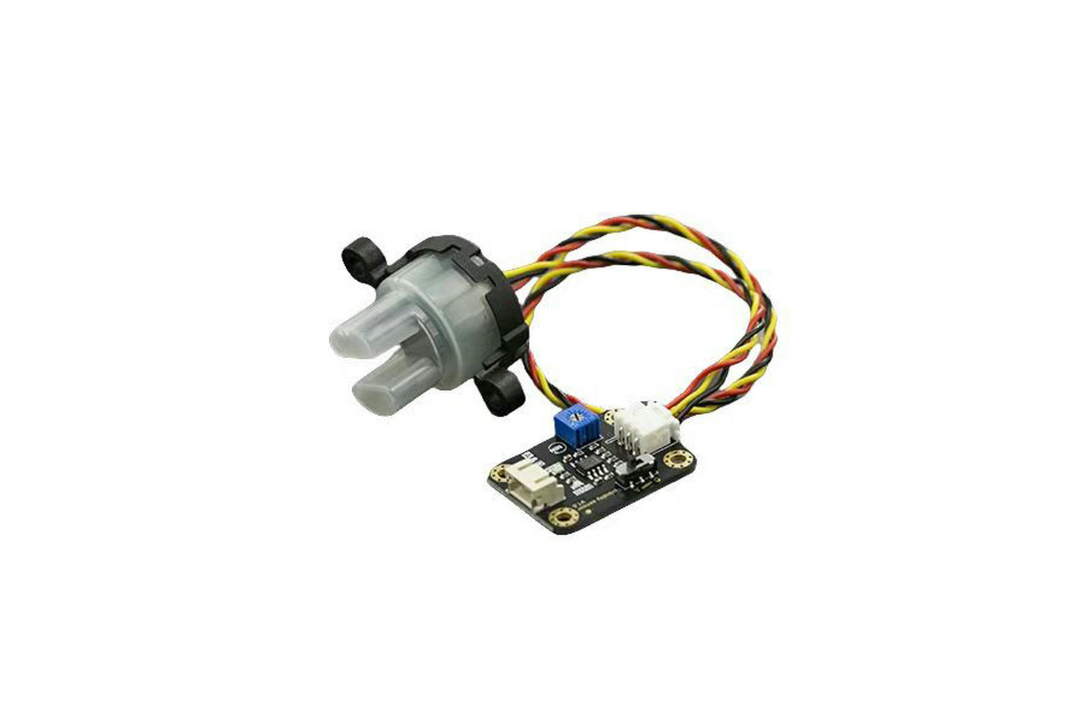
Notes:
- The potentiometer on the board is only used for setting thresholds in digital mode, but digital mode is only compatible with 5V systems, so the potentiometer won’t be useful
- Therefore, we need to use analog mode to take the exact turbidity readings in the form of a voltage, but the analog rangeis 0-4.5V, meaning we need an external ADC chip or module in between the sensor and ESP32 - 16 bit ADC module

